104年放射腫瘤科專科醫師甄審
考前題庫出題格式說明

※請依照下列步驟將考題繕打於下一頁:
- 請依下一頁範例格式繕打考題。
- 本格式已設定好樣式，故請依下一頁範例格式繕打，切勿更改其樣式。
- 開始撰打考題→先於工作列上點選”格式”，下拉式選單中點選”樣式與格式”，該樣式的格式設定將會出現在螢幕的右方，請使用該格式來控制考題的格式。
      - 點選Question:可用來控制題號(題目)
      - 點選Choice:可用來控制答案選項，自動產生A) B) C) D)，若續按Enter會繼續產生E) F)…選項，需到樣式選項點選Answer
      - 點選Answer:可用來控制答案格式(本項請再註明，出題的小組科別細項)
      - 點選QuizLevel:難易度
      - Ref:參考文獻
      - Comment:註解
- 以上步驟若無法執行，請您用複製的方式，將下頁的範例題目複製後，貼上15次，然後將原內容文字刪除，保留格式，再將新的考題內容文字加入。
「請各出題委員繕打考題時，一定要使用此格式，請勿自行變更該格式」
謝謝！

2015 – Bio
- 有關放射線造成早期細胞死亡(Early cell death)之描述，下列何者為誤？
  - 放射線照射後數小時即可發生
  - 在細胞分裂完成後快速啟動
  - 細胞凋零(Apoptosis)與其相關
  - 發生在血液方面的癌病，如淋巴瘤(Lymphoma)

    - B (輻射生物, ch3, Cell death after irradiation: how, when and why cells die)
      - 中等
        - Basic Clinical Radiobiology, Michael Joiner, Albert van der Kogel, 4th edition; Chapter 3, p33-34; 2009.
          - P33-34, Early cell death: pre-mitotic……occurs rapidly, within several hours after irradiation. Early cell death is also observed in some types of cancers that arise from these cell types, including lymphomas……Early cell death results primarily from activation of pathways in response to the initial cellular damage caused by irradiation. The best example of this is the induction of apoptosis that is initiated as part of the DDR.
- 下列描述何者為誤？
  - 低於1Gy的劑量，無法適用LQ model預估細胞反應
  - 超過1Gy才足以引發ATM傷害辨識蛋白(ATM damage-recognition protein)活化
  - 低劑量高放射敏感性(Low-dose hyper-radiosensitivity)發生於10cGy以下
  - 存活分率(Survival fraction)回彈發生於20-80cGy

    - B (輻射生物, ch4, Quantifying cell kill and cell survival)
      - 中等
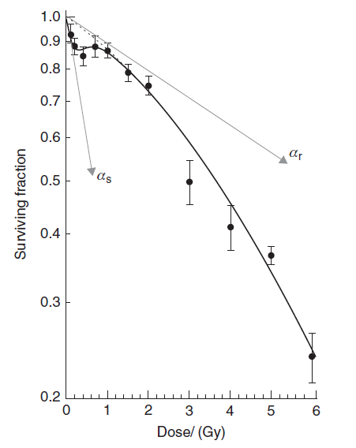
        - Basic Clinical Radiobiology, Michael Joiner, Albert van der Kogel, 4th edition; Chapter 4, p53-54; 2009.
          - P53-54, The LQ model and its mechanistic interpretations adequately describe cellular response to radiation above about 1Gy……Below about 10 cGy, the cells show HRS, which can be characterized by a slope (αs) that is considerably steeper than the slope expected by extrapolating back the response from high-dose measurements (αr). The transition (over about 20–80 cGy) from a sensitive to resistant response has been termed a region of increased radioresistance (IRR). This happens because a rapid cell-cycle arrest of cells, irradiated in the G2 phase of the cell cycle, only occurs when there are enough DNA DSBs to trigger phosphorylation of the ATM damage-recognition protein. This typically starts to happen only when the average dose exceeds about 10 cGy (Marples et al.,2003).
- 下列描述，何者為誤？
  - 達臨床上可偵測到的癌細胞數量大約為10⁹個
  - Ki67 labelling index可估測腫瘤細胞週期時間(Cell cycle time)
  - 體積翻倍時間(Volume doubling time)，肺癌細胞小於直腸癌細胞
  - 體積翻倍時間(Volume doubling time)，轉移癌細胞小於原發癌細胞

    - B (輻射生物, ch7,Tumor growth and response to radiation)
      - 中等
        - Basic Clinical Radiobiology, Michael Joiner, Albert van der Kogel, 4th edition; Chapter 7, p79-81; 2009.
          - P79, …the majority of cell doublings take place before a tumour becomes detectable, which, in most clinical situations, is when the cell number approaches about 10⁹. This cell number is equivalent to a tumour weight of about 1 g and a volume of about 1 cm³… P80, primary lung tumours double their volume every 2–6 months whereas colorectal carcinomas have been found to grow at a much slower rate with a mean VDT of about 2 years. In general, metastatic lesions tend to grow faster than primary tumours…P81, The GF can be measured in tumour biopsies, for example by immunohistochemistry, using a monoclonal antibody against the cell-cycle-specific protein Ki67. Human tumours vary considerably in their Ki67 labelling index (i.e. the ratio of cells with positive staining for the Ki67 protein divided by the total cell number)
- 關於α/β的敘述何者為誤？
  - 單位為1/Gy
  - 快速反應組織(Acutely responding tissues)其α/β約7-20
  - 晚期反應組織(Late-responding tissues)其α/β約0.5-6
  - α/β非定值

    - A (輻射生物, ch8,Fractionation: the linear-quadratic approach)
      - 易
        - Basic Clinical Radiobiology, Michael Joiner, Albert van der Kogel, 4th edition; Chapter 8, p106; 2009.
          - P106, For acutely responding tissues which express their damage within a period of days to weeks after irradiation, the α/β ratio is in the range 7–20Gy, while for late-responding tissues, which express their damage months to years after irradiation, α/β generally ranges from 0.5 to 6Gy. It is important to recognize that the α/β ratio is not constant and its value should be chosen carefully to match the specific tissue under consideration.
- 下列何者不影響EQD2？
  - 修復半期(Repair halftime)
  - 每日治療次數
  - 治療間隔(Time interval of fractions )
  - 生長分率(Growth fraction)

    - D (輻射生物, ch8,Fractionation: the linear-quadratic approach)
      - 中等
        - Basic Clinical Radiobiology, Michael Joiner, Albert van der Kogel, 4th edition; Chapter 8, p110; 2009.
          - P110, 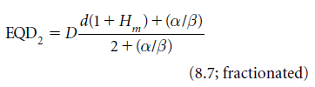 In this model, the amount of unrepaired damage is expressed by a function Hm which depends upon the number of equally spaced fractions (m), the time interval between them and the repair halftime.
- 下列描述何者為誤？
  - 幹細胞進行非對稱分裂(Asymmetrical division)，以維持幹細胞總量
  - Repopulation機制之一是無非裂能力(Sterilized)細胞再次進行數次分裂
  - 幹細胞缺失(Depletion)可引發幹細胞分裂加速(Acceleration)
  - 放射劑量越高，repopulation啟動的速度越快

    - C (輻射生物, ch11,Time factors in normal-tissue responses to irradiation)
      - 中等
        - Basic Clinical Radiobiology, Michael Joiner, Albert van der Kogel, 4th edition; Chapter 11, p152-155; 2009.
          - P152, In unperturbed tissues, stem cells divide on average into one new stem cell and one differentiating cell. These divisions are called asymmetrical because two different cells are generated. In this setting, the number of stem cells in each cell generation remains constant, independent of the proliferation rate…P153, Abortive division: ‘sterilized’ cells can undergo a limited number of divisions even after high doses of radiation…P155, In conclusion (Fig. 11.4), the asymmetry loss in the stem cell compartment is regulated independently of the acceleration of proliferation, presumably by autoregulatory processes on the basis of stem cell depletion. Acceleration of the stem cell divisions is controlled by tissue hypoplasia…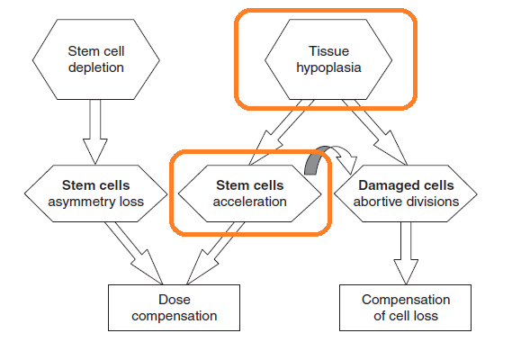 Repopulation processes that occur in early responding normal tissues follow a very complex biology. The major mechanisms are asymmetry loss and acceleration of stem cell division, as well as abortive divisions of sterilized cells.P154, It has been demonstrated that the lag time before repopulation begins is shorter, if the radiation dose is higher
- 有關早期放射反應(Early radiation effects)之描述，何者為誤？
  - 發生早期反應的潛伏期(Latent time)與放射劑量相關
  - 發生早期反應的潛伏期(Latent time)依組織種類而異
  - 早期反應的發生過程包括inflammation、hypoplasia、infection、healing
  - 早期反應亦可導致後續晚期反應(Consequential late effects)

    - A (輻射生物, ch13, Pathogenesis of normal-tissue side-effect)
      - 易
        - Basic Clinical Radiobiology, Michael Joiner, Albert van der Kogel, 4th edition; Chapter 13, P170-171, P173; 2009.
          - P170,…Moreover, early reactions can result in consequential late effects (Dorr and Hendry, 2001). P171 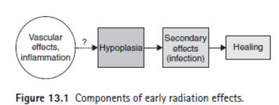 . P173, 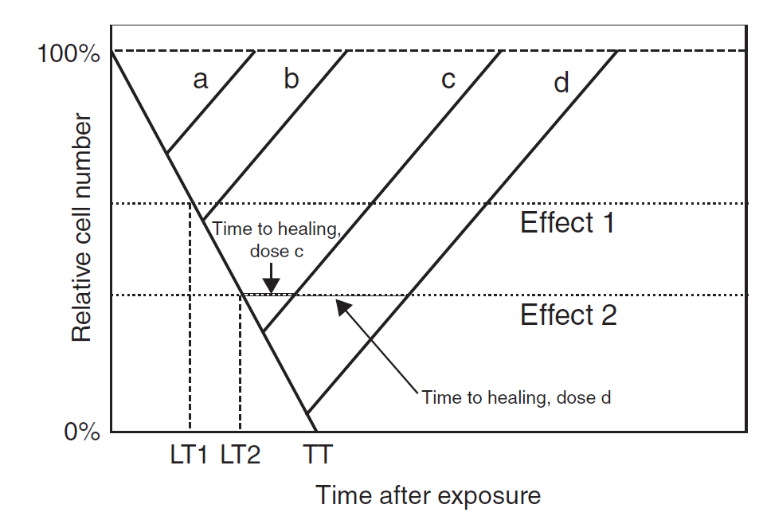 As the cell loss rate depends on the turnover time of the tissue, and is independent of the treatment, the latent time until a clinical response is reached is tissue-dependent but independent of dose
- 有關肺部的放射反應(Radiation effects)之描述，何者為誤？
  - 早期肺炎(Early pneumonitis)通常發生於放射療程後4-6週
  - 肺部纖維化(Fibrosis)通常於幾個月至幾年後發生
  - 有顯著的體積效應(Volume effect)
  - 降低單次劑量以減少放射副作用的效果不明顯

    - D (輻射生物, ch13, Pathogenesis of normal-tissue side-effect)
      - 中等
        - Basic Clinical Radiobiology, Michael Joiner, Albert van der Kogel, 4th edition; Chapter 13, P184; 2009.
          - P184, In the lung, two separate radiation syndromes can be distinguished clinically: early pneumonitis, usually observed at 4–6 weeks after the end of radiotherapy, and fibrosis, which develops slowly over a period of several months to years. The lung is among the most sensitive of late-responding organs, but with a pronounced volume effect. In addition to a reduction in irradiated volume, reduced doses per fraction are most effective in avoiding severe (clinically manifest) lung reactions.
- 下列關於缺氧(Hypoxia)的描述何者為誤？
  - 可提升Erythropoietin (EPO)的產量
  - 可篩選出抗缺氧癌細胞
  - 可引發HIF-1分解成HIF-1α及HIF-1β
  - 可引發DNA合成異常

    - C (輻射生物, ch13, The tumour microenvironment and cellular hypoxia response)
      - 中等
        - Basic Clinical Radiobiology, Michael Joiner, Albert van der Kogel, 4th edition; Chapter 16, P225-227; 2009.
          - P225, hypoxia associated with high altitude causes increased production of erythropoietin (EPO), which stimulates uptake of oxygen by promoting the differentiation of red blood cells and synthesis of the oxygen carrier haemoglobin as well as endothelial cell proliferation…hypoxia itself can evoke selection pressure against apoptosis-susceptible cells and thereby also promote the overall malignant potential of the tumour. P226, Hypoxia and reoxygenation also causes aberrant DNA synthesis, leading to over-replication and gene amplification…P227 Under hypoxic conditions, HIF-1α and HIF-2α cannot be hydroxylated and thus are not recognized by VHL. This leads to their stabilization, allowing them to bind the HIF-1β subunit and activate gene transcription.
- 有關化學治療與放射治療的交互作用或交互機轉，何者為誤？
  - 空間協同作用(Spatial cooperation)
  - 藉由化學治療使腫瘤縮小，使再氧化(Re-oxygenation)提升
  - 細胞週期同步化(Cell-cycle synchronization)
  - 提高癌細胞分裂性衰敗(Mitotic catastrophe)

    - D (輻射生物, ch18, Combined radiotherapy and chemotherapy)
      - 中等
        - Basic Clinical Radiobiology, Michael Joiner, Albert van der Kogel, 4th edition; Chapter 18, P248-253; 2009.
          - P248-253, INTERACTION BETWEEN CHEMOTHERAPY AND RADIOTHERAPY: Spatial cooperation, Independent cell kill and “shared” toxicity, Cellular and molecular interaction. MOLECULAR MECHANISMS OF INTERACTION BETWEEN CHEMOTHERAPY AND RADIOTHERAPY: Enhanced DNA/chromosome damage and repair, Cell-cycle synchronization, Enhanced apoptosis, Re-oxygenation, Inhibition of cell proliferation

